

|  |  |  |
| --- | --- | --- |
|  | **AIRLINE** **RESERVATION** |  |
|  | **SYSTEM** |  |
| C PROGRAMMING PROJECT  SRM AP AIRLINE RESERVATION 1 | | |

• TABLE OF CONTENTS

|  |  |
| --- | --- |
| **Contents** | **Page** **No** |
| Project Title | 3 |
| Technical Requirements | 4 |
| Algorithm / Flowchart | 5 |
| Sample Input output |  |
| C source Code |  |
| End User |  |
| Conclusion |  |

SRM AP AIRLINE RESERVATION 2

**Project** **Title** : *SRMAP* *AIRLINE* *RESERVATION* *SYSTEM*

**Aim** : The aim of project is to Book airline tickets through C Programming.

**Group** **details** : Saloni Bangar Saithej Singhu

Sunil Reddy Yellaie

AP20110010385 AP20110010388 AP20110010423

**Objective** **:** Purpose of this project is to make Automated Airline Reservation System through C Programming.

SRM AP AIRLINE RESERVATION 3

**Technical** **Requirement** **:** We need a software which can compile and run C programs. Software we required to complete this project is Dev-C++.

**About** **Project** : In recent times Air Travel is one of major transport systems. By keeping that in mind we developed a simple but effective Airline ticket reservation Project in which user needs to login by entering his/her Passport number, Name ,and Mobile number. And after logging in we can choose 4 options as Reservation , Cancel , Show records , Exit. We can book tickets in reservation section and we can cancel booked tickets and also displays our booked tickets from its records.

**Project** **Status** : We successfully completed the project by dividing our work into three as algorithm designing, code building and finally code refining .We hope we made it perfect with no errors and flaws.

SRM AP AIRLINE RESERVATION 4

**Project** **Algorithm** **/** **Flowchart** **:**

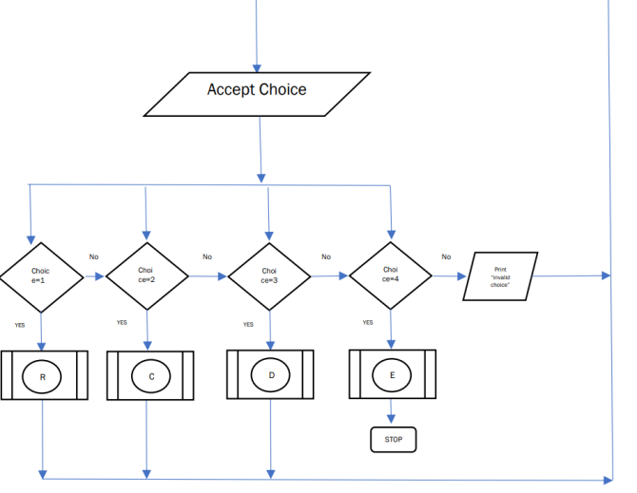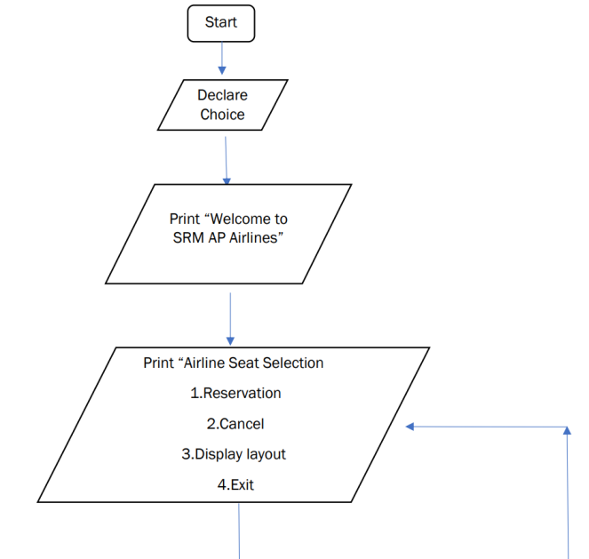

SRM AP AIRLINE RESERVATION 5

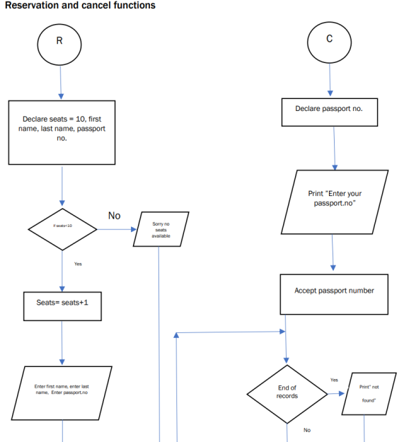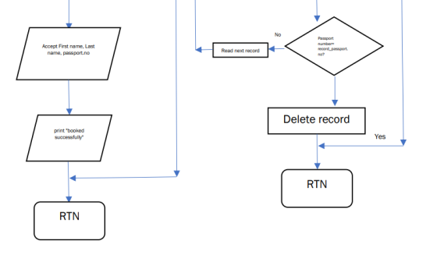

SRM AP AIRLINE RESERVATION 6

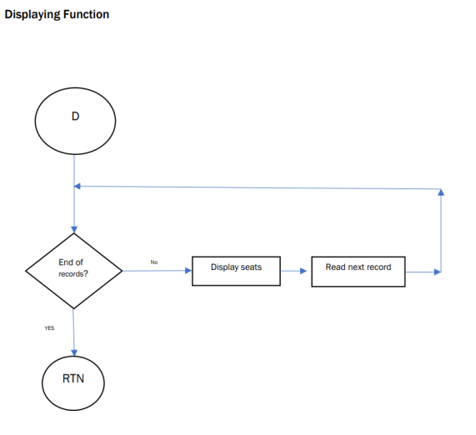

SRM AP AIRLINE RESERVATION 7

SRM AP AIRLINE RESERVATION 8

SRM AP AIRLINE RESERVATION 9

SRM AP AIRLINE RESERVATION 10

SRM AP AIRLINE RESERVATION 11

SRM AP AIRLINE RESERVATION 12

SRM AP AIRLINE RESERVATION 13

SRM AP AIRLINE RESERVATION 14

**C** **Source** **Code** **:**

******************************");

#include<stdio.h> #include<stdlib.h> #include<conio.h> #include<string.h> #include<Windows.h>

struct SRMAP_airline {

char passport[6]; char name[15]; int seat_num; char email[15];

struct SRMAP_airline*following; }

*begin,*stream;

struct SRMAP_airline*dummy;

void main() {

void reserve(int x),cancel(),display(),savefile(); int choice;

begin=stream=NULL; int num=1;

do {

system("cls"); system("color B1");

printf("\n\n\t\t**************************************

"); printf("\n\t\t Welcome to SRMAP's Airline System

SRM AP AIRLINE RESERVATION 15

****printf("\n\n\t\t*********************************** printf("\n\n\t\t1.Reservation"); printf("\n\n\t\t2.Cancel");

*****************************");

printf("\n\n\t\t3.DISPLAY RECORDS"); printf("\n\n\t\t4.EXIT");

printf("\n\n\t\tChoose your option from 1 to 4:- "); scanf(" %d",&choice);fflush(stdin);

system("cls"); switch(choice) {

case 1: {

reserve(num); num++; break;

} case 2:

{

cancel(); break;

} case 3:

{

display(); break;

} case 4:

{

savefile(); break;

SRM AP AIRLINE RESERVATION 16

}

//************************************srmap

begin=stream=(struct

default:

printf("\n\n\tSORRY INVALID CHOICE!"); printf("\n\n\tPLEASE CHOOSE FROM 1-4");

} getch();

}while(choice!=4); }

void details() {

printf("\n\tEnter your passport number:"); gets(stream->passport);fflush(stdin); printf("\n\tEnter your name:"); gets(stream->name);fflush(stdin); printf("\n\tEnter your email address:"); gets(stream->email);fflush(stdin);

}

airlines************************************

void reserve(int x) {

system("color 75"); stream=begin;

if (begin==NULL) {

//first user

SRMAP_airline*)malloc(sizeof(struct SRMAP_airline)); details();

stream->following=NULL; printf("\n\tSeat booking successful!");

printf("\n\tyour seat number is:SeatA-%d",x); stream->seat_num=x;

SRM AP AIRLINE RESERVATION 17

return; }

stream->following=(struct

//************************srmap

else if(x>15)//FULLSEATS {

printf("\n\t\tSeatFull."); return ;

}

else {

//nextuser

while(stream->following) stream=stream->following;

SRMAP_airline*)malloc(sizeof(struct SRMAP_airline)); stream=stream->following;

details();

stream->following=NULL; printf("\n\tSeat booking succesful!");

printf("\n\tyour seat number is:SeatA-%d",x); stream->seat_num=x;

return; }

}

airlines******************************** void savefile()

{

system("color C0"); FILE*fpointer=fopen("SRMAPrecords","w"); if(!fpointer)

{

printf("\nError in opening file!"); return;

Sleep(800);

SRM AP AIRLINE RESERVATION 18

}

);//SRMAP RECORDS

//********************************srm ap

=================*++");

stream=begin; while(stream) {

fprintf(fpointer,"%-6s",stream->passport); fprintf(fpointer,"%-15s",stream->name); fprintf(fpointer,"%-15s",stream->email); stream=stream->following;

}

file" printf("\n\n\n\n\n\n\t\t\tDetails have been saved to a printf("\n\n\n\t\t\tTHANKS FOR VISITING US :)"); fclose(fpointer);

}

airlines***************************************

void display() {

system("color F4"); stream=begin; while(stream)

{

printf("\n\n\nPassport Number:%-6s",stream->passport); printf("\n name:%-15s",stream->name);

printf("\n email address:%-15s",stream->email); printf("\n Seat Number:A-%d",stream->seat_num);

=== printf("\n\n++*=================================

SRM AP AIRLINE RESERVATION 19

stream=stream->following; }

//*****************************srmap

}

airlines*************************************

void cancel() {

system("color E6"); stream=begin; system("cls"); char passport[6];

printf("\n\nEnter passort number to delete record?:"); gets(passport);fflush(stdin);

if(strcmp(begin->passport,passport)==0) {

dummy=begin; begin=begin->following; free(dummy);

printf("booking has been deleted"); Sleep(800);

return; }

while(stream->following) {

if(strcmp(stream->following->passport,passport)==0) {

dummy=stream->following;

stream->following=stream->following->following; free(dummy);

printf("has been deleted"); getch();

Sleep(800);

SRM AP AIRLINE RESERVATION 20

return; }

port");

airlines**********************************

stream=stream->following; }

pass printf("passport number is wrong please check your }

//************************************srmap

SRM AP AIRLINE RESERVATION 21

**End** **User** : As our project is Airline reservation system end user of this project will be Airline’s customers who are willing to purchase Airline tickets for their Destinations.

**Conclusion**: The Airline reservation system is designed for users to reserve a seat , cancel, Displays and exit the system. A formula is included in the function to calculate the seats are reserved.

Pseudocode is written for some important codes . A few flowcharts are also created for explaining the process of the Airline reservation system. From this assignment ,We have learnt to implement a few C concepts in the future projects such as functions , switch statement and do…while statement, arrays ,pointers and structures in the program.

SRM AP AIRLINE RESERVATION 22

THANK YOU

SRM AP AIRLINE RESERVATION 23